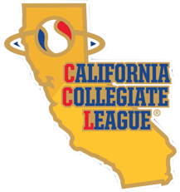
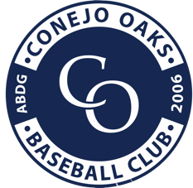

Internship Application
Conejo Oaks Baseball
Summer 2021 – Thousand Oaks, CA

The Conejo Oaks is a summer collegiate baseball organization that assists in the development of college baseball players throughout the United States. The Oaks are sponsored by Amateur Baseball Development Group (ABDG), a non-profit organization founded in the summer of 2004 by Mike Scioscia, Kevin Muno and Randy Riley. The Conejo Oaks are a member of the very respected California Collegiate League. The Conejo Oaks play a 35-40 game schedule during the summer, focusing on player development.

The Oaks have begun an internship program to assist college students looking for a future in various aspects of sports. Internships are available in the areas of:

Game Day Operations Social Media Statistical Analysis/Scouting
Athletic Training Radio Broadcast
Full Name: |  |  |  | Date:
 | Last | First

Address:
 | Street Address | Apartment/Unit #

 | City | State | ZIP Code

Phone: |  | Email

What Position are you applying for?

Can you give 100% commitment to the position you are applying for? (put an “X”) | YES |  | NO |  | OTHER

What college will you be attending for fall 2021?

What year in college will you be in fall 2021?

Do you have any experience working in baseball or sports? (not required)

Why do you want to work with the Conejo Oaks?

*After filling out this form save it and send it to Director of Operations, Rebecca Willson, conejooaksinfo@gmail.com along with a cover letter or resume.

*IF YOU ARE APPLYING TO THE BROADCASTER/PRODUCTION position you will need to email tapes or links to tapes of previous broadcasts you have done along with this application and cover letter or resume.

